### 8th August 2016

### YOKOHAMA to Make Hose Piping for Oil Supply Lines of Toyota GD Turbo Diesel Engines

Tokyo – The Yokohama Rubber Co., Ltd., announced today that its Teflon hose piping for use in the oil supply lines of turbo-diesel engines has been adopted by Toyota Motor Corporation for use in some of its new Hilux equipped with Toyota’s new GD engines, developed in 2015. The use of Teflon hoses reduces the steps and man-hours required to mount oil supply lines. YOKOHAMA began manufacturing the Teflon hose piping at its Nagano Plant in February 2015 and transferred production to Yokohama Rubber (Thailand) Co., Ltd., from January 2016.

In recent years, engine layouts have become more compact, resulting in tighter spaces for mounting oil lines in turbo diesel engines and making it more difficult to reduce the man-hours required to mount conventional pipe lines. To solve this problem, YOKOHAMA applied its proprietary technologies in metal fittings and hoses to greatly simplify the mounting process by using flexible Teflon hoses. To meet high quality requirements, YOKOHAMA separated manufacturing processes and redesigned a production line, enabling it to produce one product at a time. The Company also devised a number of other solutions, including the development of jigs to simplify product testing, that have reduced the time required to produce a finished product.

Toyota is manufacturing the GD engines at a plant in Thailand and plans to use the engine in cars sold in more than 150 countries and regions by 2020.

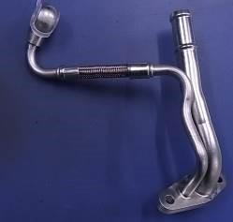

***Teflon hose piping***